25.7: Consider 1 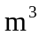 of silver.
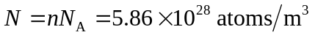
If there is one free electron per This agrees with the value given in Exercise 25.2.

